North American Motorcycle Tourists

in Northern Ontario (RTO13)

A situation Analysis

Executive Summary

Prepared for

Tourism Northern Ontario

by

Research Resolutions & Consulting Ltd.



March 2014

Contents

Introduction 3

Executive Summ ary 5

Overview of Motorcycle Tourists 5

Trip Activities 7

Canadians 7

Americans 8

Surrogate Estimates of Volume & Value 8

Dreams and Economic Realities 10

Describing the Indescribable 11

# Introduction

Northern Ontario’s spectacular vistas and winding roads are a “natural” for the motorcycle touring segment. And indeed, this segment has long been identified as a promising market for Northern Ontario. In conjunction with Ontario Tourism Marketing Partnership Corporation (OTMPC), Northern Ontario has devoted considerable effort to developing routes and promotional materials to attract motorcycle tourists.

Each of RTO13’s sub-regions has developed motorcycle touring routes, either wholly contained within the region or in conjunction with neighbouring jurisdictions. For example, the Lake Superior Circle Tour traverses roadways in Northern Ontario, Michigan, Minnesota and Wisconsin while Ride Manitoulin is fully contained in Ontario.

|  |  |  |
| --- | --- | --- |
| **Examples of Motorcycle Touring Routes in Northern Ontario** | | |
| Manitoulin Island Tour | Lake Nipissing Tour | St. Joseph Island |
| Georgian Bay Coastal Route | Lake Superior Circle Tour | Waterfall & Scenic Lookouts |
| Great Legends Tour | Deer Trail | Ride the Giant |
| Lake Temiskaming Tour | Grand Algoma Tour | Nor'Wester |

Recreational motorsports continue to be among the products featured in OTMPC’s 2014/2015 marketing strategy.[1] At the same time, according to Tourism Northern Ontario’s latest marketing strategy, *unprompted awareness of tourism products is low, and core products like angling, hunting, and* ***motorsports rank low*** *amongst consumers when defining unique experiences in the region*.[2]

In the continuing effort to grow the motorcycle touring market for RTO13, Tourism Northern Ontario commissioned Research Resolutions & Consulting Ltd. to undertake a situation analysis. Unlike analogous projects recently completed by the firm on behalf of Tourism Northern Ontario, very little recent *consumer data* is available on the motorcycle touring market segment.[3]

For example, the major Statistics Canada tourism surveys do **not** capture information about motorcycling as a tourism activity.[4] Research Resolutions asked representatives of Northern Ontario’s sub-regional tourism and economic development departments to supply information on the volume and characteristics of motorcycle tourists in their jurisdictions. They graciously provided *anecdotal* information but indicated that information on market size, spending and other characteristics of motorcycle tourists is not collected in a systematic manner. In response to a series of questions about motorcycling tourism volume and characteristics in a sub-region, one representative provided a description that is likely indicative of other parts of Northern Ontario: *unfortunately, tourism marketers do not have the skills or resources to track this information*.[5]

**Good Background Reading**

Reports and studies that provide considerable background on the opportunities and challenges of developing and promoting product for motorcycle touring in Ontario are listed below. Readers are encouraged to review these findings in conjunction with this report.

***Motorcycle Market Readiness Report, Region 13 B & C, 2011***

The project focusses on how to increase tourism spending as a result of route development and refinement in Regions 13 B & C. (Available from Carol Caputo, [carol@algomacountry.com](mailto:carol@algomacountry.com))

***Ontario Parks Guide to Motorcycle Readiness***

A guide to help Ontario become more motorcycle friendly, providing simple, easy to follow advice. (Available from Carol Caputo, [carol@algomacountry.com](mailto:carol@algomacountry.com))

***Understanding and Attracting the On-Road Motorcycle Tourism Market to Northern Ontario*** was prepared in 2006. This report provides an overview of motorcycling touring, including vehicle types and sales, opportunities for on-road motorcycling experiences in Northern Ontario and other communication and product development information. (<http://www.tourismpartners.com/publications/IndustryResources/MotorcycleTouring.pdf>)

***2011 Ontario’s Southwest Motorcycle Tourism Report***. This report focuses on a regional inventory of motorcycle-friendly products and development of a marketing strategy for Southwest Ontario. (http://swotc.ca/wp-content/uploads/Motorcycle-Tourism-Project.pdf)

Consequently, there are no reliable estimates of the volume, characteristics, spending or economic impact of motorcycle tourists in Northern Ontario.[6] In the absence of reliable volumetric information, this report focuses on the following:

* Demographic and trip characteristics of Canadian and American motorcycle tourists who have travelled in Northern Ontario or Ontario on pleasure trips over a two-year period (from the Travel Activity and Motivations Study [TAMS]) [7]
* A discussion about the motivations for *motorcycle touring* per se, based on a literature review; and
* Industry data on motorcycle sales and registrations in the U.S. and Canada.

# Executive Summ ary

## Overview of Motorcycle Tourists

***Who are “motorcycle tourists”?***

*The Travel Activities and Motivation Surveys (TAMS) captures activities and places visited on overnight pleasure trips over a two-year period but does* ***not*** *provide a link between activities and specific locations.*

*Thus, in this report motorcycle tourists in Northern Ontario or Ontario are:*

* *Adults (18+) who have taken overnight pleasure trips to* ***any destination*** *over a two-year period; and*
* *Rode a motorcycle during at least one of their overnight pleasure trips in the past two years.*

***The motorcycling experience could have been on a trip to Northern Ontario/Ontario or any of the other destinations visited over the two-year span.***

**One-fifth of Canadian motorcycle tourists or about 107,000 have travelled in Northern Ontario over a two year period.[8]**

There are approximately one half million Canadians who claim to ride motorcycles while on overnight pleasure trips (543,000)and about one fifth of them have travelled in Northern Ontario over a two-year period.

Because so many Canadians travel near where they live, it is not surprising that Northern Ontario attracts riders who live in Ontario at an especially high rate. The region enjoys visits by 76,000 or half of the 153,000 motorcycle tourists who live in the province. Over one quarter of Manitoba’s 11,000 riders are also visitors to Northern Ontario (3,000).

About 40,000 motorcycle tourists live in Toronto and approximately half of them, or 20,000, have travelled in Northern Ontario, making Torontonians the single largest potential domestic market for the region.

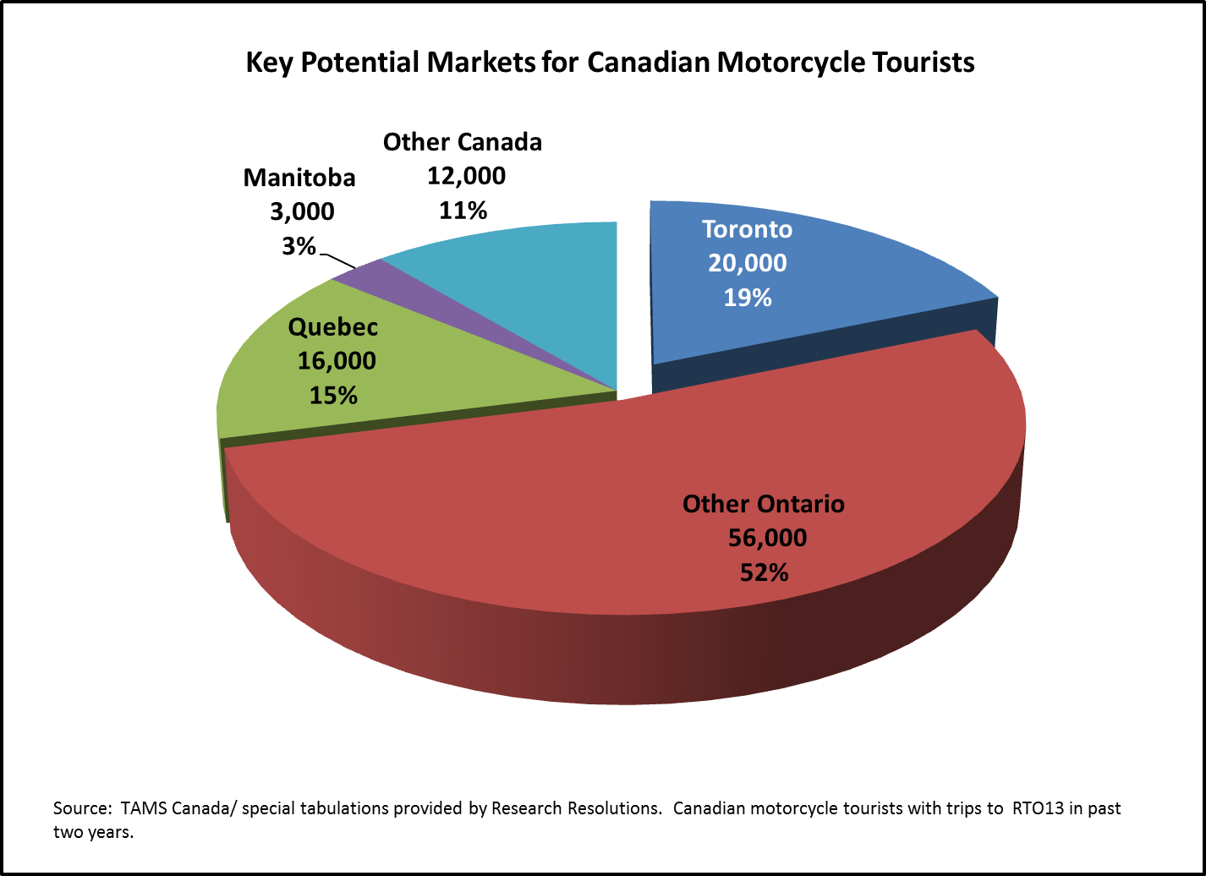

**Only a fraction of American tourists who ride motorcycles while on trips have Canadian travel experience.**

While there are about 5.1 million motorcycle tourists in the U.S.A., those who travel anywhere in *Canada* represent about 844,000 or 16%.

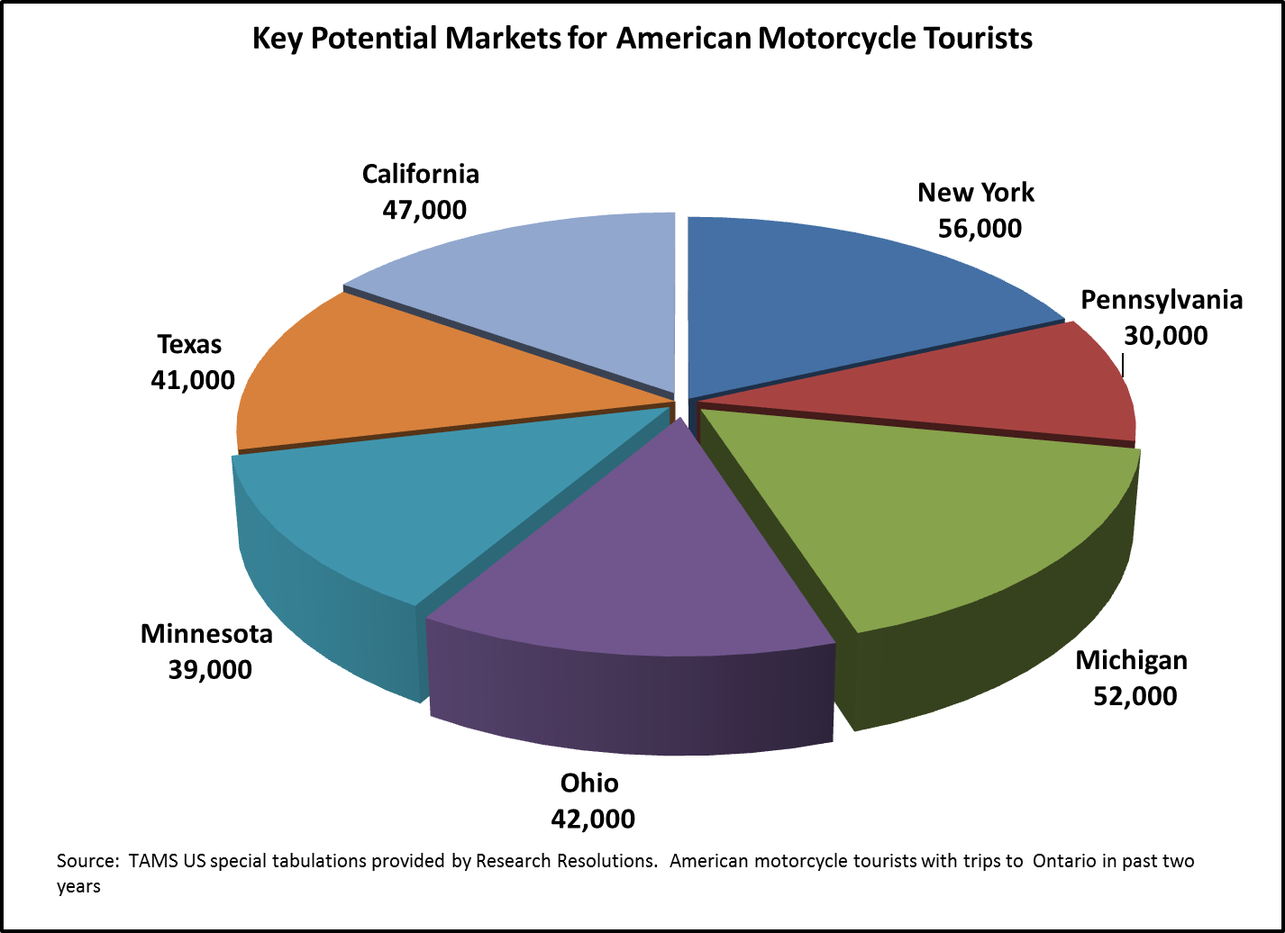Within the 844,000 motorcycle tourists with Canadian travel experience, 473,000 have travelled in Ontario over a two year period with about 106,000 of them claiming to have travelled in Northern Ontario over the same time period. For analysis purposes, the 473,000 American motorcycle tourists with **Ontario** experience are regarded as Northern Ontario’s broadly defined market, with about 300,000 identified as key target markets for the region (displayed in the accompanying chart).[9]

These tourists live across the U.S. and, like all American motorcycle tourists, tend to be concentrated in *fair weather* regions such as California and Texas. Over 40,000 of the motorcycle tourists from each of these states have been to Ontario on overnight pleasure trips.

They join motorcyclists from Northern Ontario’s more traditional markets such as New York (56,000), Michigan (52,000), Ohio (42,000) and Minnesota (39,000) to create a potential of over 300,000 motorcyclists for the province and its North (sum of tourists displayed in the accompanying chart).

**The potential Canadian and U.S. markets for Northern Ontario share some demographic characteristics.**

Most are men, concentrated in the middle age and recently-retired age groups. The Canadian market is concentrated in the 35 to 44 year age bracket (39%) whereas almost half of the Americans are between 45 and 64 years of age (47%). These differences result in a somewhat older motorcycle touring market among Americans (45 years, on average) than Canadians (39 years of age, on average).

**American motorcycle tourists to Ontario are somewhat less affluent than the corresponding Canadians.**

Half of Canadian motorcycle tourists travelling in Northern Ontario have household incomes of at least $100,000 (54%) whereas less than one third of the Americans are in this income group (29%). Industry analysts suggest that the many American motorcycle tourists are recent retirees or nearing retirement from primarily blue collar occupations.

## Trip Activities

### Canadians

**Motorcycling is the primary reason for the trip to take place for about half of the potential Canadian market.**

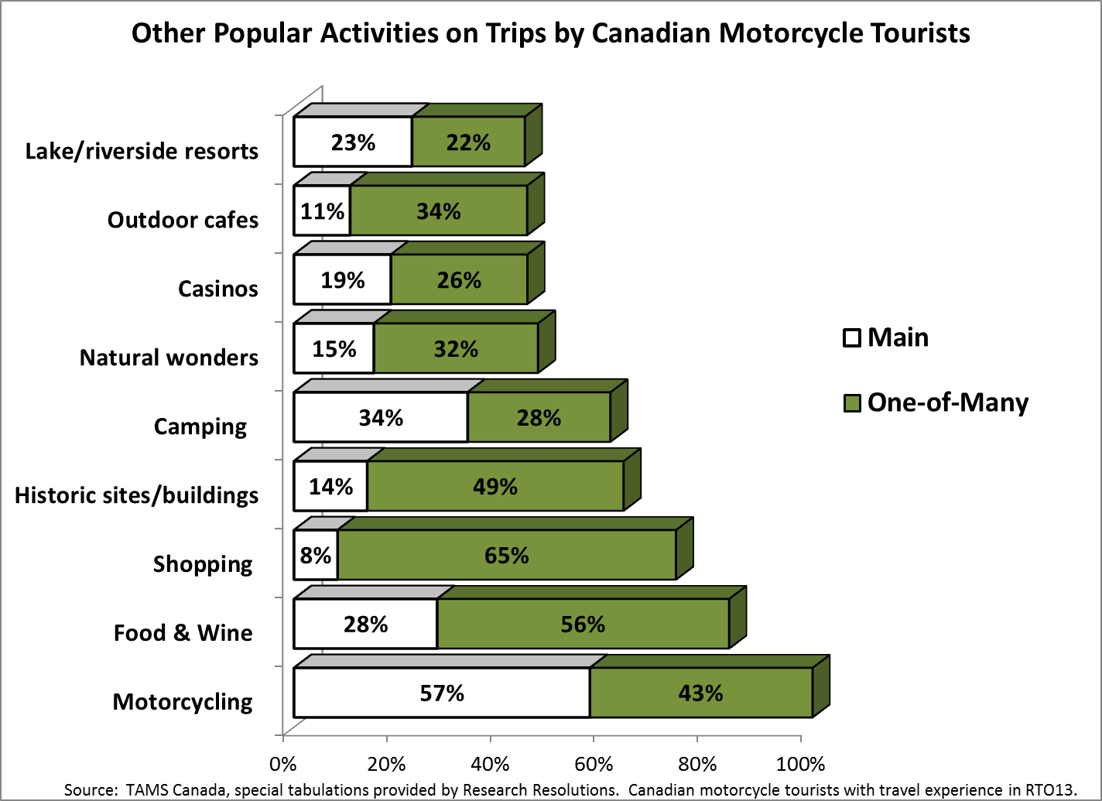For the remaining riders, motorcycling is one-of-many activities in which they engage on overnight pleasure trips (43%). Camping (34%), various culinary pursuits such as dining in high quality restaurants (28%) and staying at lake or riverside resorts (23%) are the only other activities to be deemed trip drivers by at least one quarter of Northern Ontario’s potential Canadian motorcycle tourists. These activities, along with shopping and going to historic sites or strolling in cities to view architecture form part of the experiences sought by most domestic motorcycle tourists either as the primary reason for a trip or as one of many activities.

Additionally, about one half of Canadian riders who have travelled to Northern Ontario visited natural wonders, casinos and/or outdoor cafes as a main or other activity on recent trips.

**Those *missing* from the list of popular trip activities among Canadian riders are of particular importance for Northern Ontario.**

These Canadians do not seem drawn to many of the North’s signature experiences. For example, comparatively few of them engage in outdoor adventure pursuits such as fishing, hiking, viewing wildlife or flora and the like. Similarly, with the exception of viewing historic sites and buildings and natural wonders, these motorcycle tourists have limited interest in many cultural activities such as visiting museums, art galleries, and live theatre or music performances.

### Americans

**American motorcycle tourists with Ontario travel experience, like their Canadian counterparts, are slightly more likely to consider motorcycling as the *main* reason for a trip than as one-of-many trip activities.**

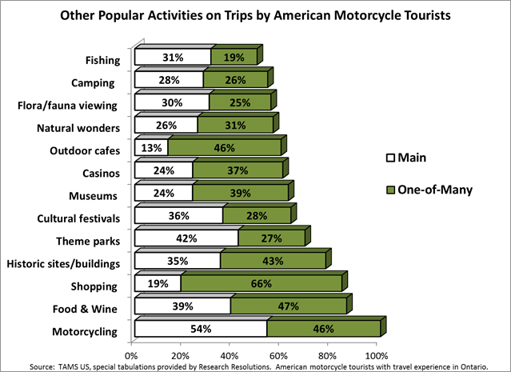 At the same time, the Americans exhibit a broader range of activity preferences than do their Canadian counterparts (see chart).

Recall, however, that unlike their Canadian counterparts, the Americans in Northern Ontario’s potential market have taken international trips. As such, they are likely to be more adventuresome travellers than those who take their motorcycling trips in their own country

Of particular salience for Northern Ontario is the fact that Americans in the potential motorcycle tourist market go camping, fishing and wildlife/wildflower viewing on their trips: activities that might be packaged on motorcycling tours in the region.

## Surrogate Estimates of Volume & Value

**Volumetric and diagnostic information about how many and which motorcycle tourists are on Northern Ontario’s routes would fill an important void for tourism operators and marketers.**

A key challenge in undertaking this project has been the absence of reliable volumetric information on the size and economic importance of motorcycle touring in Northern Ontario.[10] To remedy this information gap, Northern Ontario Tourism is encouraged to establish measurement systems to learn more about the people who are actually riding through Northern Ontario on their motorcycles. Why? Realistically, the primary source of tourism statistics – the Statistics Canada domestic and international tourism surveys – are unlikely to capture motorcycle tourism data in the foreseeable future.

Hence, the responsibility to initiate a research program that provides *hard* information on the volume and value of this niche segment will likely fall to provincial and regional authorities. In the mid- and long term, it would also be useful to obtain input from motorcycle tourists about their experiences in Northern Ontario so the region can refine its offering to capture a larger number of them.

To provide at least a broad sense of volume and spending by motorcycle tourists in the region, Research Resolutions has provided surrogate estimates based on Statistics Canada’s tourism surveys (see below) but readers are encouraged to interpret them with caution.

**Based on surrogate estimates, approximately 47,000 to 58,000 North American motorcycle tourists would have been travelling in RTO13 over the course of a year.** [11]

About half of these overnight motorcycle tourists are estimated to be Canadians (53%) and the balance are Americans (47%). Each of RTO13’s sub-regions is estimated to attract overnight motorcycle tourists, with about one quarter of the market spending nights in 13A, one third in 13B and two fifths in 13C.

**These motorcycle tourists are estimated to have spent between $16.0 million and $20.0 million in Northern Ontario over a year.**

Because American tourists spend appreciably more in RTO13, on average, than do their Canadian counterparts, they represent a much larger share of spending (71%) than they do of motorcycle tourist volume (47%) in the region.[12]

Region 13C is the most successful sub-region in drawing American motorcycle tourists. Because it attracts a higher share of Americans and Americans spend more money, on average, than do Canadians, 13C is estimated to attract over half of the estimated motorcycle tourist spending in RTO13. One fifth of Northern Ontario’s motorcycle tourists’ dollars would have been spent in 13A and about one quarter in 13B.

**Motorcycle touring is a niche market for Northern Ontario.**

Based on these estimates, the motorcycle touring market is clearly a niche market for Northern Ontario. For example, this market likely brings appreciably smaller numbers of tourists to the region than do fishing or non-consumptive nature-based activities. The figures below represent *actual* overnight person visits in RTO13 over a year by Canadians and Americans who engage in the stated activity while on their trip to the North.

|  |  |
| --- | --- |
| **North American Overnight Trips in Northern Ontario** | |
| Fishing | 1,060,000 (actual) |
| Nature/Outdoors* | 792,000 (actual) |
| Hunting | 76,000 (actual) |
| Motorcycling | 47,000 to 58,000 (estimated) |
| Actual estimates from TSRC 2010; ITS US 2011, overnight person trips in Northern Ontario with specified activity. *Excludes hunting/fishing | |

## Dreams and Economic Realities

**Motorcycle touring is commonly characterized as “the stuff of dreams”.**

For many, motorcycle riding is a post-retirement indulgence people can afford once they are empty nesters, have the financial wherewithal to purchase an expensive machine and have the time to take extended holidays. No wonder a severe economic downturn dampened many of these dreams: in 2008/2009 there was appreciably less discretionary income and a lot more worry about the future.

**Motorcycle sales fell dramatically on both sides of the border following the 2008/2009 recession.**

In Ontario, almost 21,000 new units were sold in 2007 but only 12,200 were sold in 2012 (-41%). Sales fell at about the same rate across Canada as a whole (-38%). A similar decline in sales hit the U.S. during the most recent recession. Industry sources indicate that sales of on-highway motorcycles reached approximately 611,000 units in 2008 whereas only about 318,000 new units were sold in 2011 (-48% over four years).

Recovery from the deep downturn has been slow, with only marginal growth in sales over the past couple of years. In light of these sales data, those building tourism products for the motorcycle segment should consider how closely tied this market is to general economic conditions.

## Describing the Indescribable

**Motorcycle tourists are difficult to pigeon hole.**

They come from every walk of life, travel individually, in groups or with a partner; take day rides and touring *holidays*; they plan their trips in advance or make impromptu decisions about where and when to travel. In light of their high degree of diversity, it is impossible to characterize *all* or even *most* motorcycle tourists. Nonetheless, some commonly cited attributes and attitudes are provided here to lend colour to the profile of the motorcycle tourists Northern Ontario wants to attract.

**Many motorcycle tourists seek winding back roads and beautiful vistas.**

Whether citing *Zen and the Art of Motorcycle* *Maintenance* or a motorcycle tourist explaining why he rides, for many motorcycle tourists, *it’s the ride rather than the destination* that attracts them.

*On a cycle the frame is gone. You're completely in contact with it all. You're in the scene, not just watching it anymore, and the sense of presence is overwhelming.[13]*

*One of the most distinct things about riding is that nothing feels quite like a motorcycle; the thrill of being at one with a two-wheeled machine that weighs only a few hundred pounds is one of the purest ways to get from point A to B, and the risks involve sometimes even heighten that enjoyment.[14]*

**Camaraderie and fraternity are important to many motorcyclists.**

In one study, two thirds of motorcyclists cite camaraderie as a reason to ride. From 40% to 60% are estimated to be club members.[15] Many purchase and wear clothing and accessories to highlight their “group” identity. Hence, it is not surprising that they commonly take touring trips with a group of buddies or, much less commonly, with a partner. They also attend rallies such as those held in Port Dover or Sturgis North Dakota. At events such as these, motorcycle tourists are looking for a “good time”.

**Many motorcycle tourists favour smaller, family-owned businesses.**

These might include B&Bs, non-chain motels, mom-and-pop coffee shops and diners with a welcoming attitude toward motorcyclists. These types of business are perceived to offer good value and customer service.[16]

**Motorcycle tourists have no clear preferences for lodging options while on a vacation touring trip.**

Instead, during the ten to fourteen days they claim to be on motorcycle vacations annually, these tourists use a wide range of accommodation with considerable duplication. Campgrounds, motels and the homes of friends and relatives are especially popular. [17]

**Being “motorcyclist welcoming” means understanding the practicalities of travelling on a motorcycle.**

For example, small gas tanks and limited baggage capacity dictate the need for touring routes with refuelling and refreshment opportunities every couple of hours or so.

Some amenities help create a *motorcycle-friendly* impression. These could include coat racks with shelves for helmets, storage areas for gear, secure parking areas away from cars and trucks and/or installing a sign signalling that *motorcycles are welcome*.[18]

1. OTMPC 2014 – 2015 Marketing Strategy, page 21: *Products: hunting, fishing,* ***recreational motorsports****, nature and adventure and cities and attractions.*
2. *Partnerships for a Strong Tourism Industry,* Northern Ontario Tourism Marketing Strategy 2012-2017.
3. Other reports have focused on high yield anglers, high yield nature/outdoor tourists (excluding those who hunt or fish), hunters and snowmobiling tourists.
4. Travel Survey of Residents of Canada (TSRC); International Travel Survey (ITS).
5. See Appendix for contacted representatives and the questions they were asked.
6. Very approximate estimates of the volume and spending by motorcycle tourists in RTO13 are provided, based on numerous assumptions applied to the TSRC and ITS US studies. These estimates should be interpreted with extreme caution.
7. The base size for American motorcycle tourists who have been to Northern Ontario is too small to warrant detailed analysis. Instead, the report focuses on Americans in the motorcycle target market who have travelled in any part of Ontario over a two-year period.
8. These are Canadians who have visited RTO13 over a two-year period and also rode a motorcycle on at least one of their overnight leisure trips. The motorcycling may or may not have taken place in RTO13.
9. Americans who have taken overnight pleasure trips to Ontario are used in this analysis because the base size of those with Northern Ontario travel experience in the TAMS US survey is too small to warrant detailed scrutiny. Recall that American motorcycle tourists who have visited Northern Ontario or other parts of the province may or may not have engaged in motorcycling while on their trips to these destinations.
10. Research Resolutions asked representatives of Northern Ontario’s sub-regional tourism and economic development departments to supply information on the volume and characteristics of motorcycle tourists in their jurisdictions. These representatives indicated that while this type of information would be very valuable, it is not collected in a systematic manner. See Introduction for more discussion of this topic.
11. Data derive from data from the Travel Survey of Residents of Canada and International Travel Survey (US).

    Assumptions:

    (1) A motorcycle tourist will name a “motorcycle” when asked to identify the main mode of transportation used in Canada;

    (2) estimates include Canadians and Americans on overnight trips with at least one night spent in RTO13;

    (3) motorcycles are included in the “other” category of main transportation mode in the surveys, but this category also includes bicycles and travelling on foot (e.g., hikers). Estimates of volume presented here assume that between 60% and 75% of overnight visitors to RTO13 in the “other” mode category are motorcycle tourists.

    The lower estimate assumes 60% and the higher estimate assumes that 75% of “other” main mode overnight travellers are on motorcycles.
12. Spending estimates are calculated using average per person Canadian overnight visitor spending in RTO13 at $187.00; Americans at $519.00 (all modes, all purposes).
13. Robert M. Pirsig, *Zen And The Art Of Motorcycle Maintenance: An Inquiry Into Values*.
14. Why Ride a Motorcycle? Basem Wasef, <http://motorcycles.about.com/od/motorcyclingbasic1> /ss/Why_Ride.htm.
15. This is a voluntary, non-random study conducted among over 700 *beltdrivebetty.blogspot.ca* subscribers during 2007/2008. Information should be interpreted with caution.
16. *Ontario’s Southwest Motorcycle Tourism Report*, June 2011, pg. 21.
17. This is a voluntary, non-random study conducted among over 700 *beltdrivebetty.blogspot.ca* subscribers during 2007/2008. Information should be interpreted with caution.
18. *Ontario’s Southwest Motorcycle Tourism Report*, June 2011, pg. 22